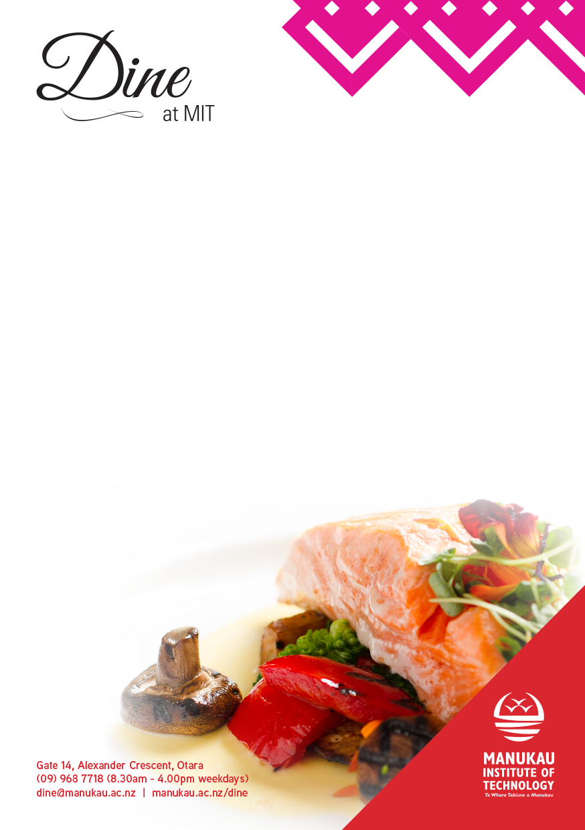

***FOOD ALLERGY?***

*Management advises that food prepared here at DINE may contain or have come in contact with peanuts, tree nuts, soybeans, milk, eggs, wheat, shellfish or fish. Please ask our staff about the ingredients in your meal before placing your order.*

*As indicated below these meals* ***may*** *be served as*

***(GF)*** *= Gluten Free,* ***(V)*** *= Vegetarian*



**Tahua Tina | Lunch Menu from 11:30am**

**Kai Nui | Main………………………………..…………………………………….……$10.00 each**

**Beer Battered Market Fish & Chips**,Pea Pesto & Brinjal Relish

**The Pantry Cheese Burger**, Pickles, Relish, Kewpie Mayo & Fries

**Warm Flatbread** w Fresh Tomatoes, Basil, Ricotta & Prosciutto

**Purïni Reka | Dessert……………………………………………………………………$5.00 each**

**Dessert Trolley – an assortment of delicious sweet desserts**

***At busy times your food may take a little bit longer to reach your table.***

***Your food is being freshly prepared by our students***

***with a lot of love thrown in for good measure.***

***Please sit back, relax and enjoy!***

www.servedoncampus.co.nz